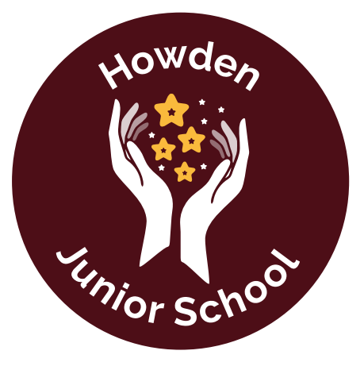
Howden Junior School
Executive Headteacher: Mr L Quinn-Hill
Headteacher: Mrs C Isitt
Curriculum Coverage LTP – Year 4

 | Autumn 1 | Autumn 2 | Spring 1  Journey through  Africa | Spring 2  Iron Man | Summer 1  Water | Summer 2  Water
Focus Subject | Geography | Science/Geog | History | Geography | History | Geography
Writing – Fiction | Wishing Story:  The King of the Fishes  Focus: Dialogue | Adventure Stories –  Adventure at Harrow Woods  Focus: Setting and character |  | Portal Story  Planet Circurion  Focus: Description | Defeating the Monster Story  Beowulf  Focus: Suspense and action
Writing – Non-Fiction | Discussion  (Should Howden School have a dog?) | Explanation  (The Marmalade Making Machine)  Apply:  The Water Cycle | Persuasive letter |  |  | Recount: Newspaper report
Poetry | So small? Joan Poulson  Pictures in my mind  Joan Poulson  Meet at the Horizon  Matt Goodfellow | The River - Valerie Bloom  Fisherman Chant John Agard | Multicultural Poetry (African Focus)  The Magic Box  Kit Wright | Calligrams  The A to Z of animals  The Towering Giant  The Robot | The Dragon of Death - Jack Prelutsky  A Dragon’s Lament  Jack Prelutsky  Walking with my Iguana  Brian Moses
Reading - Fiction (Novels) | Charlotte’s Web | The Song of the Dolphin Boy | The Butterfly Lion | Iron Man | Beowulf | The Explorer
Reading - Fiction (Picture Books) | One Plastic Bag and the Recycling Women of the Gambia  Miranda Paul | Flotsam  David Weisner  The Rhythm of the Rain  Graham Baker-Smith | Mama Panya’s Pancakes  One plastic bag | The Wild Robot  Peter Brown |  | Journey to the Riversea
Reading - Non Fiction |  | The Rhythm of the Rain  Explanation texts - Water Cycle | Meet the Ancient Egyptians  James Davies  So you think you’ve got it bad  Chase Strasie |  | Tidy Emily Gravitt  Window Jeannie Baker | The Land of Neverbelieve
Geography | Europe  Greece | Water Cycle  Rivers |  | Africa (Wondrous World Week) |  | Rainforests (Amazon)
History |  |  | Ancient Egypt |  | Vikings/Anglo Saxons
Science | Digestion  Teeth  Food chains | States of Matter |  | Electricity | Sound | Living Things and their Habitats
Science | Working Scientifically ongoing
Art | Storytelling through drawing | The Art of Display |  | Still Life | Exploring pattern  Coil pots  (Viking style) | Festival Feasts
Design and Technology | Pavilions (Structures) |  | Fastenings  (Textiles)  Purse/phone case - back stitch |  | Torches (Electricity) | Cooking (rainbow salad) Grating, cheese, carrot, cabbage, etc  Vinaigrette dressings
R.E. | Communities  Where is religion? | Christmas-Light: why is light an important symbol of Christmas? | People who inspire us: What makes a Saint? | Easter-The Cross:  What is its significance throughout the Easter Story? | Our world:  Who cares?
French | iLanguages
Music | Charanga  Harvest celebration | Charanga | Charanga | Charanga | Charanga | Charanga
Computers | Online Safety and effective searching 4.2/4.7 | Writing for different audiences 4.4 | Coding 4.1 | Spreadsheets 4.3  Artificial intelligence 4.10 | Hardware  Investigators and Logos 4.8/4.5 | Animation (puppet pals)  4.6  Making music 4.9 (in place of music lessons)
PSHE RSE | Being me in my world | Celebrating difference | Dreams and goals | Healthy me | Relationships | Changing me
PE | Tag Rugby  Gymnastics | Dance  Fitness | Swimming  Dodgeball | Swimming  Netball | Athletics  Cricket | Tennis  OAA
Educational Visits and Enrichment activities |  | Airmyn/Hook |  | Howsham Mill/Siemens | Residential? York - Jorvik Centre? | Cooking - raising money for charity
Links to values | Community | Curiosity | Community | Care | Curiosity | Care

