**Howden Junior School** 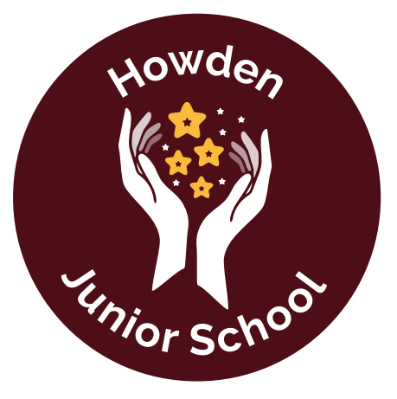

Executive Headteacher: Mr L Hill

Headteacher: Mrs C Isitt

**Curriculum Coverage LTP – Year 3**

|  |  |  |  |  |  |  |
| --- | --- | --- | --- | --- | --- | --- |
|  | **Autumn 1**  **SECRET AGENTS** | **Autumn 2**  **STONE AGE** | **Spring 1**  **RAMPAGING ROMANS** | **Spring 2**  **SURVIVAL**  **Antarctica/Asia** | **Summer 1**  **MADE IN YORKSHIRE** | **Summer 2**  **SAVE THE BEES** |
| **Writing - Fiction** | The Red Eye  Suspense | Persuasive letters | ‘Bloddon’s Quest’  Quest |  | Jamil’s Clever Cat  Rags to Riches |  |
| **Writing – Non-Fiction** | Instructions | Recount |  | Report (non-chronological) |  | Explanation  Why are the number of bees declining? |
| **Reading - Poetry** | Ghost in the Garden  Berlie Doherty  The Ghostly Visitor  Roger Stevens | Performance Poetry:  Talking Turkeys - Benjamin Zephaniah | Narrative Poetry:  Storm Poetry |  | My Sari    ~~An Emerald is as Green as Grass~~  ~~Christina Rosetti~~  ~~The Paint Box~~  ~~E.V. Rieu~~ | Judith Nicholls  Poems on a theme: nature  Classic poems  Garden of Verses  My Garden  Benjamin Zephaniah |
| **Reading – Fiction**  **(+ Picture Books)** | Agent Asha  Secret Agent Elephant | Stig of the Dump  Stone Age Boy | Ice Palace | The Firework Maker’s Daughter | James and the Giant Peach | The Boy Who Grew Dragons |
| **Reading Non-Fiction** | How to Cook Children  a grisly recipe book  Martin Howard and Colin Stimspon | Who Were the First People? | Who Were the Romans? | Range of texts about Antarctic animals |  | Nature’s Tiny Miracles Bees  What On Earth: Bees |
| **Geography** | Local Study: Maps and Field Work |  |  | Wonderous World:  Antarctica  Asia - China |  | Counties, Cities and  Regions of Yorkshire |
| **History** |  | Stone Age  Focus on Tools/  Weapons/ Homes | Romans |  | Amy Johnson - Local Hero |  |
| **Science** | Forces and Magnets | Rocks and Soils | Bones and Skeletons | Health and Exercise | Light | Plants |
| Working Scientifically ongoing | | | | | |
| **Art** | Gestural Drawing with Charcoal (Cave Art)  **Artists**: Laura McKendry, Edgar Degas |  | Working with Shapes and Colour  **Artists:** Henri Matisse, Claire Willberg | Cloth, Thread, Paint (Linked to Antarctica)  **Artists:** Alice Kettle, Hannah Rae | Telling stories through drawing and making -  **Artists**: Quentin Blake, Inbal Leitner, Henry Moore, Barbara Hepworth | Making Animated Drawings (Link to plants/bees)  **Artists:** Lauren Child |
| **Design and Technology** | Mechanical systems - pneumatic toys |  | Textiles - stitch and applique cushion |  | Digital World - Smart wearables | Cooking and nutrition- Eating Seasonally  (Fruit Tart - peeling and chopping) |
| **R.E.** | Remembering: Why Remember? | Christmas – Mary Mother of Jesus | Founders of Faith: Who, what and when? | Easter: The Events of Holy Week | Sacred Places: What is sacred? |  |
| **French** |  |  | iLanguages | | |  |
| **Music** | Charanga - Developing notation skills | Christmas  Performance | Playing in a band. | Charanga - Music from around the world | Charanga - Graphic Scores | Charanga - recognising different sounds. |
| **Computers** | Introduce Google Drive  Online safety  Touch Typing | Presenting and researching (GS)   Graphing | Email and Email Safety | Branching Databases  Simulation | Coding Programming | Spreadsheets |
| **PSHE RSE** | Being in my world | Celebrating difference | Dreams and Goals | Healthy Me | Relationships Big Talk | Changing Me |
| **PE** | Fundamentals  Bench Ball | Outdoor Adventure Activities  Gymnastics | Ball skills  Dance | Hockey  Football | Tennis  Basketball | Rounders   Athletics |
| **Non negotiables** | Harvest | Christmas Production |  | World Book Day  Wondrous World  Week  Easter |  | History through the Decades |
| **Educational Visits and Other Ideas** | Howden Secret Agent Mission - Howden trip  Find the missing trophy |  | Roman Afternoon | China afternoon |  | Save the Bees Parent open event |